h  Who the service is available to:  - The service is available to adults who are socially isolated in the community.  - The service is available to adults with an identified mental health need or a physical need and where these needs are impacting on their ability to function/undertake activities of daily living.  - Where the need is impacting on the persons physical/emotional/cognitive or social wellbeing.  - Where the need is impacting on the carers ability to continue to provide care.  Referral Process:  - Those deemed via financial assessment as self-funding for their care can self-refer by contacting their chosen centre.  - Referrals are made via Adult Social Care 0345 60 80 191  - An allocated social worker or Resource officer will complete a care & support assessment.  - Once support requirements are agreed a referral for the service will be sent to us  - A home visit will be completed by Day service staff to gather information about the individuals support needs and interests. | Milton Grange  Milton Road  Old Town  Eastbourne  BN21 1SL  01323 466450  Milton.GrangeDayService@eastsussex.gov.uk  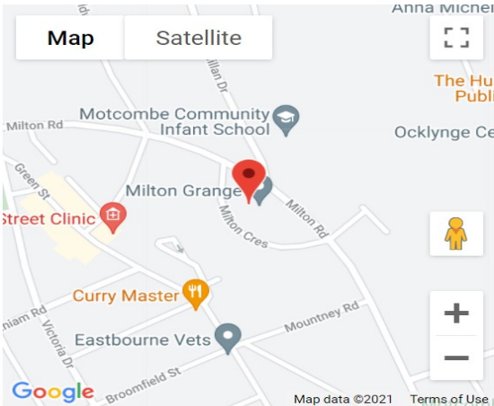  Who are we and what do we do?  As part of Adult Social Care, Older peoples Day Services provides physical and cognitive stimulation through a range of activities Including Reminiscence, indoor bowls, arts & crafts, cooking, chair- based exercises, trips out to local locations and many more.  Staff are trained in all aspect of care supporting clients with their personal hygiene, medication, eating & drinking and those with complex mobility.  Hours  Milton Grange operates between 8:30am-16:30pm, weekdays only. Closed on Bank Holidays.  Fees  Current cost is broken into 3 elements:  - £53.50 for the day service  - £5 for the meal (Homemade on site)  - £ 1 each way for transport (Funded clients only)  A person’s fees will be decided through a financial assessment completed by their social worker. |   Older Peoples  Day  Services  

The Team  The day service team is made up of highly skilled support workers, senior support workers and a management team. | Our main aims are:  - To Assess peoples needs and produce support plans reflecting these and ensuring they are met.  - To work as a team alongside other professionals, agencies, and family members/carers to provide a high level of care.  - To provide and inclusive and accessible service  - To provide a person-centred service that respects choice, dignity, and privacy.  - To provide the highest quality service | We can offer:  - A safe and friendly environment  - Support and advice for carers and families.  - A support mechanism for carers that prevents early admission into long term care.  - Social, physical, and mental stimulation through a range of activities  - Nutritious, healthy and delicious meals  - Safe travel to and from the day service via our range of accessible vehicles  - An allocated key worker to support clients during their visits and hold regular reviews with carers/family.

