h  Who the service is available to:  - The service is available to adults who are socially isolated in the community.  - The service is available to adults with an identified mental health condition or a physical need and where these needs are impacting on their ability to function/undertake activities of daily living.  - Where the need is impacting on the persons physical/emotional/cognitive or social wellbeing.  - Where the need is impacting on the carers ability to continue to provide care.  Our main aims are:  - To assess a person’s needs and produce support plans reflecting these and ensuring they are met.  - To work as a team alongside other professionals, agencies, and family members/carers to provide a high level of care.  - To provide and inclusive and accessible service  - To provide a person-centred service that respects choice, dignity, and privacy.  - To provide the highest quality service | Milton Grange  Milton Road  Old Town  Eastbourne  BN21 1SL  01323 466450  Milton.GrangeDayService@eastsussex.gov.uk  Hours  Milton Grange operates between 8:30am-16:30pm, Monday – Friday (excluding bank holidays).  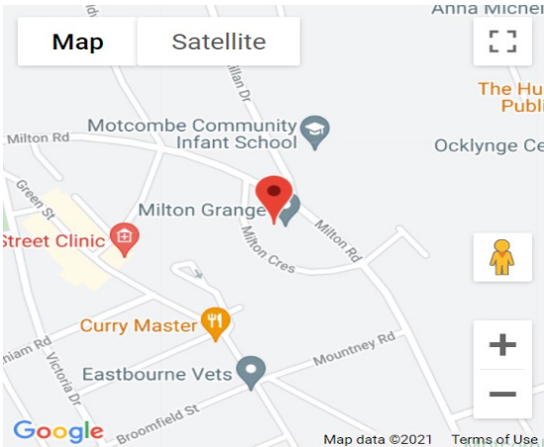    Who are we and what do we do?  As part of Adult Social Care, Day Service provides physical and cognitive stimulation through a range of activities Including Reminiscence, indoor bowls, arts & crafts, cooking, chair- based exercises, trips out to local places of interest and many more.  Staff are trained in all aspect of care and supporting people with their personal hygiene, medication, eating & drinking, behaviours that could be seen as challenging and those with complex mobility needs.  Fees  You will need to pay the full cost of attendance if your capital is more than £23,250 or you do not wish to have a financial assessment.  If you pay the full cost for care arranged by the council, such as Day Services, there are two extra costs that also apply – a one-time set up fee and an ongoing administration charge.  You are likely to contribute towards the cost of attendance if your capital is less than £23,250.  Currently meals and transport (to and from home) charges are on top of the contribution you pay to attend the service.  We will refer you for a financial assessment and you may be contacted for further information and will receive a letter once this is completed.  If you believe you may be eligible for support towards the cost of your care, please review the ‘What you will need to pay booklet’ and contact health and Social Care Connect on 0345 6080191 for further support  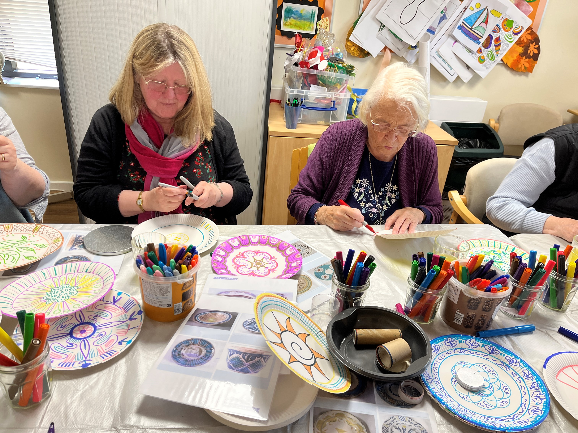 |   Milton Grange  Day  Service  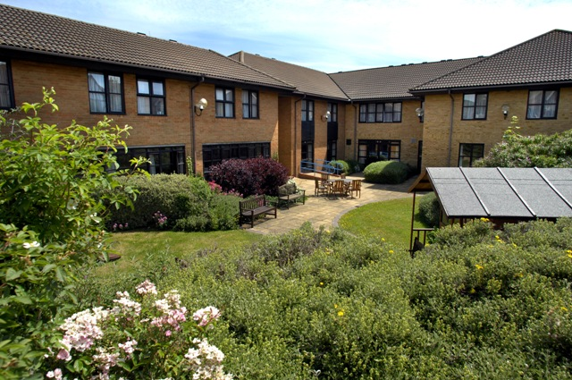

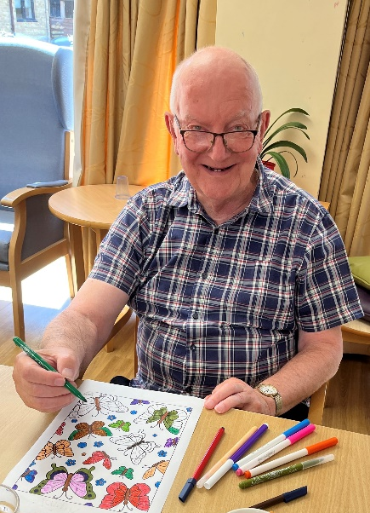  The Team  The day service team is made up of highly skilled support workers, senior support workers and a management team. | How to access the service:  - For further information or to book a free taster session please call or email us  - Or contact Heath and social care connect on 03456 080 191 | We can offer:  - A safe and friendly environment  - Support and advice for carers and families.  - A support mechanism for carers that prevents early admission into long term care.  - Social, physical, and mental stimulation through a range of activities  - Nutritious, healthy, and delicious meals  - Safe travel to and from the day service via our range of accessible vehicles for people who are eligible.  - An allocated key worker to support people during their visits and hold regular reviews with carers/family.

