
Other services
Hairdressing – we have a hairdresser in attendance on various days in the week (prices are displayed in the salon).
Chiropody – arrangements can be made for a chiropodist to visit.
Newspapers – we have a variety of newspapers delivered or clients can opt to have their own newspaper delivered.
Optician – arrangements can be made to see an optician if required.
Dentist – visits can be arranged if required.
Mobile Shop - We have a mobile shop which comes around the units to purchase toiletries, snacks, and activities. We also have a small aid shop where you can purchase everyday living aids such as sock aids and leg lifters.
We have a modern gym facility with exercise equipment used to enhance physical rehabilitation.
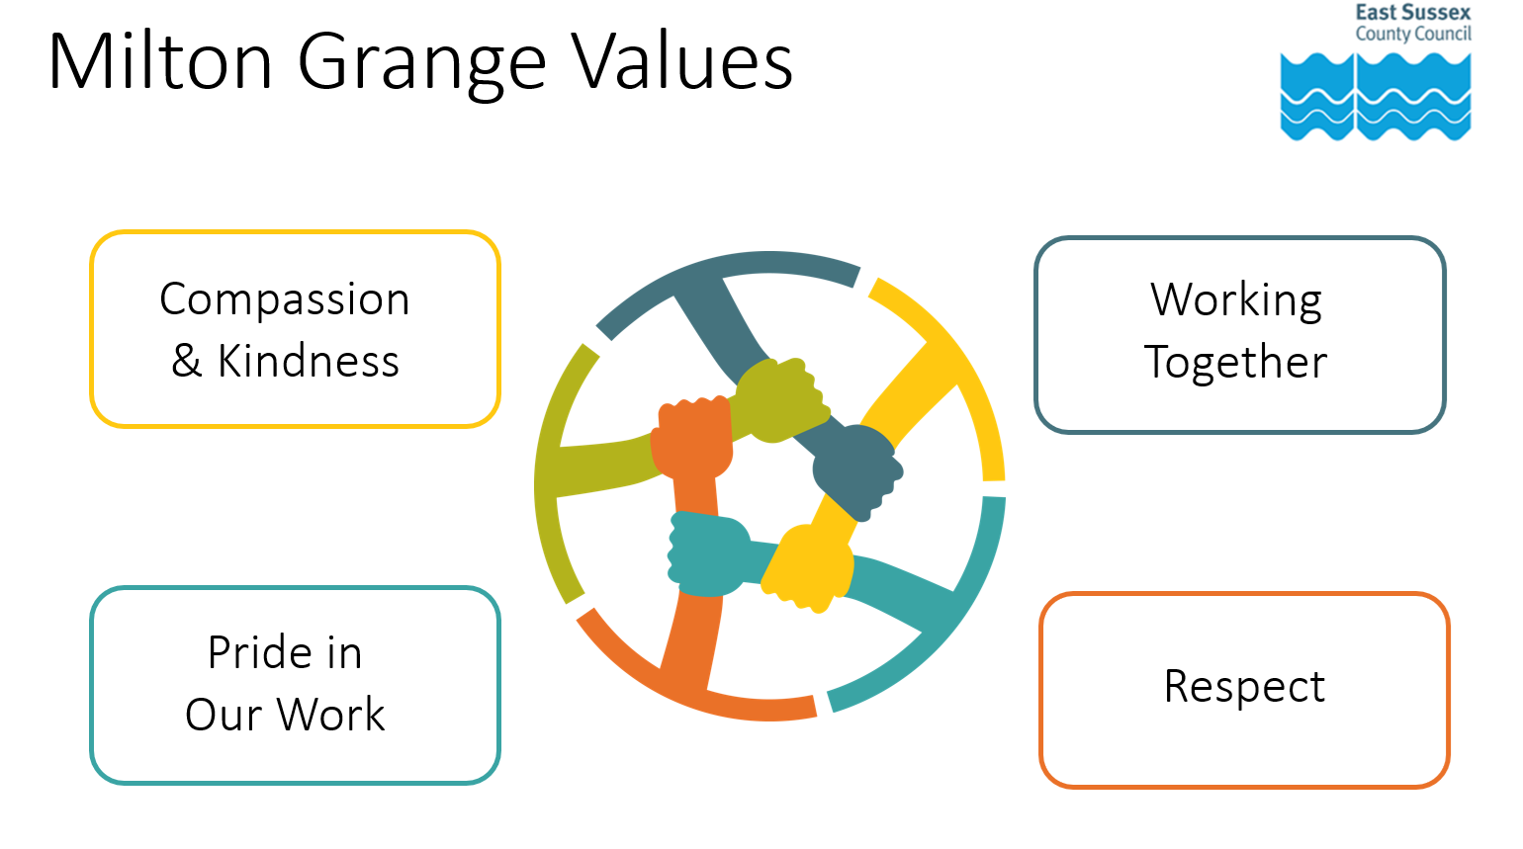
How to find us
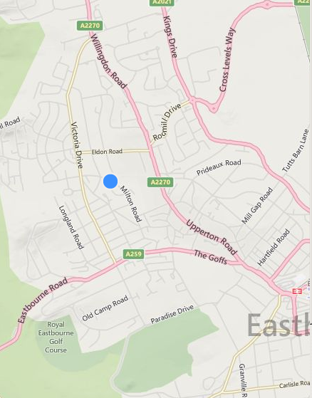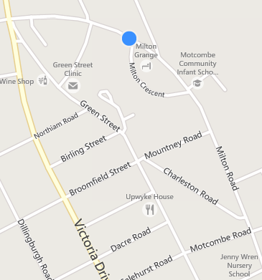

Milton Grange
Milton Road
Old Town
Eastbourne
BN21 1SL
Tel: 01323 466466

miltongrange.referralline@escc.gov.uk

Getting more copies of this leaflet:
You can get all our leaflets in large print, easy read format in Braille, on
audio tape or CD, or in other languages. Please phone Health and Social Care Connect 0345 60 80 191. They are also available in PDF form, which you can download from our website at eastsussex.gov.uk

March 2025

Milton Grange Intermediate Care

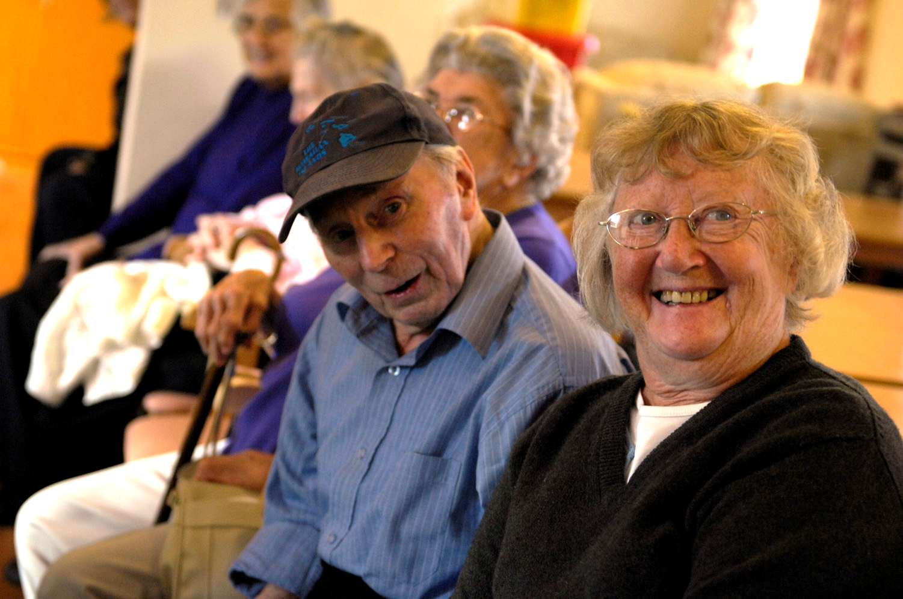



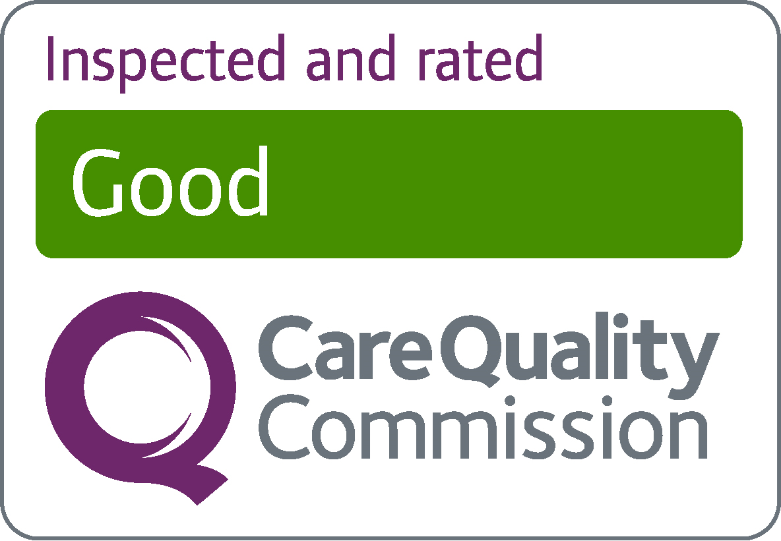
Activities
There are a variety of activities to take part in catering for all needs. For example, board games, quizzes, films, and music appreciation as well as the opportunity to take part in chair- based exercises.
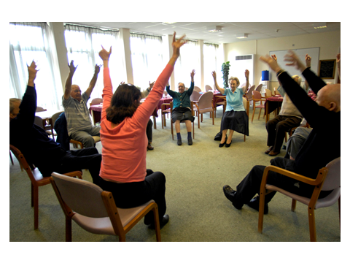
Wi-Fi Internet
We have a public Wi-Fi system, which means you will be able to access the internet from most areas, including your bedroom, using your own phone, laptop or tablet. Staff will be happy to assist you with accessing this.
Meals
All our meals are freshly prepared on site and meal choice can be selected for the following day. We can provide a selection of meals including vegetarian, diabetic, Kosher and Halal.
Day Centre
We have a Day Centre on site catering for up to 45 places on weekdays, excluding Bank Holidays.
Accommodation
Accommodation comprises of a fully furnished single bedroom with emergency call bells and smoke detectors. All bedrooms have an en suite shower, toilet, and washbasin (there are also assisted baths available) and each room is equipped with a plasma TV.
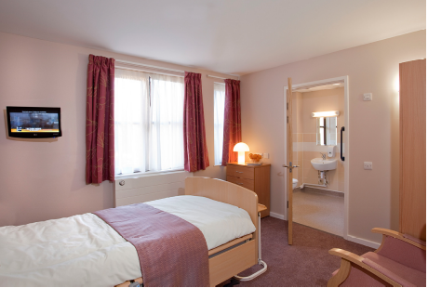
Each unit is self-contained with its own lounge, kitchen and dining room.

We have a large garden with a decking area at the rear of the building with seating areas. There are raised planted beds and a sensory garden to enjoy when the weather allows.
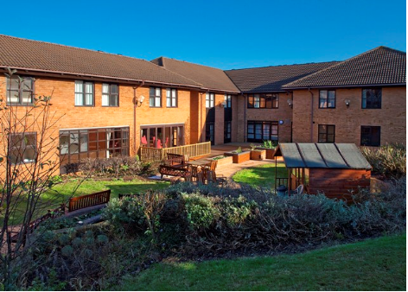
About Us
Milton Grange is an East Sussex County Council facility regulated by The Care Quality Commission (CQC). Reports are available online at www.cqc.org.uk
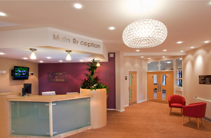
Our vision at Milton Grange is to assess, improve or restore a person’s quality of life after illness or injury through a multidisciplinary rehabilitative process. We also support people with mental health needs to make decisions about their care.
Staff consider all aspects of a person’s needs – Physical, psychological, social, and environmental. This support can make a real difference giving a renewed sense of purpose, opening up new horizons, which may change the way a person feels about their future.
Our team find ways to support people to manage daily tasks and activities. This might include finding support initially with self-care, accessing the community, prescribing equipment, or taking part in social and leisure activities.

